## Scotia Sea Myctophid Analysis

### Species

* M = 0.14 to 0.30
  + 95% HDI range of 10,000 replicates: 0.01 to 0.04
* M is significantly different between species.
  + Kruskal-Wallis test (Chi-sq = 49.82, df = 5, P = 2.44*10^-9)

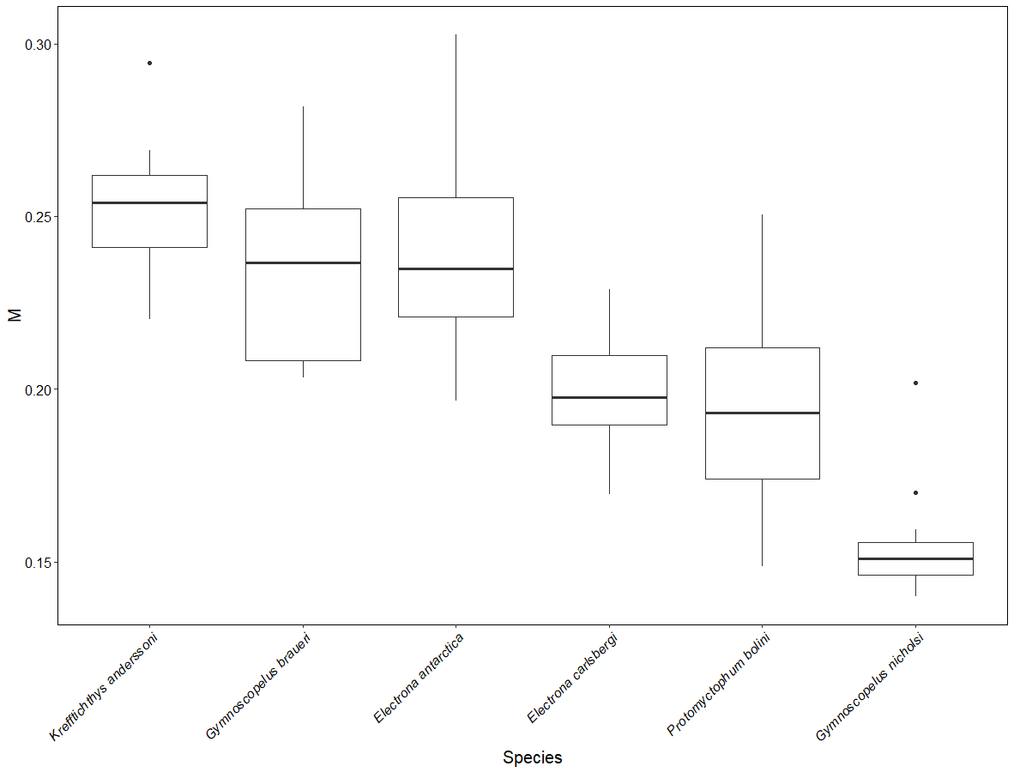

* K. anderssoni, G. braueri and E. antarctica all have higher M values.
* G. nicholsi, P. bolini and E. carlsbergi all have lower M values.
  + Dunn test with Bonferroni correction.

|  |  |  |  |  |  |  |
| --- | --- | --- | --- | --- | --- | --- |
|  | E. antarctica | E. carlsbergi | G. braueri | G. nicholsi | P. bolini | K. anderssoni |
| E. Antarctica |  | <0.05 | N/S | <0.01 | <0.01 | N/S |
| E. carlsbergi | <0.05 |  | <0.1 | N/S | N/S | <0.01 |
| G. braueri | N/S | <0.01 |  | <0.01 | <0.02 | N/S |
| G. nicholsi | <0.01 | N/S | <0.01 |  | N/S | <0.01 |
| P. bolini | <0.01 | N/S | <0.02 | N/S |  | <0.01 |
| K. anderssoni | N/S | <0.01 | N/S | <0.01 | <0.01 |  |

### Temperature and log10(weight)

* No significant linear relationship between M and temperature, log10(weight) or the interaction.

|  |  |  |  |  |
| --- | --- | --- | --- | --- |
| **Model** | **a** | **b** | **R-Squared** | **p-Value** |
| **M ~ Temperature + (1|Species)** | 0.21 | 0.00 | 0.50 | 0.13 |
| **M ~ log10(Weight) + (1|Species)** | 0.21 | 0.00 | 0.53 | 0.24 |
| **M ~ Temperature * log10(Weight) +(1|Species)** | 0.22 | **T**  0.00 | 0.49 | **T**  0.11 |
| **W**  0.00 |
| **W**  0.64 |
| **T*W**  0.00 | **T*W**  0.74 |

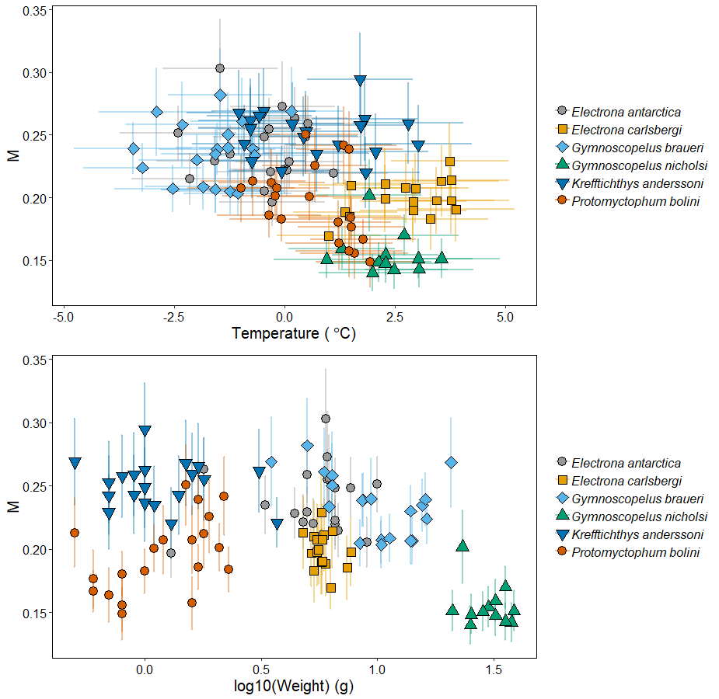

## Myctophid Comparison

### D18O

* Higher d18O than Sherwood & Rose fishes.
  + At lower temperatures.
* G. nicholsi and E. carlsbergi plot within 95% HDPI.
* K. anderssoni, E. Antarctica and G. braueri (and P. bolini, just) all plotting below the line.
  + Lower d13C than expected given d18O.
  + High metabolic rate for temperature.

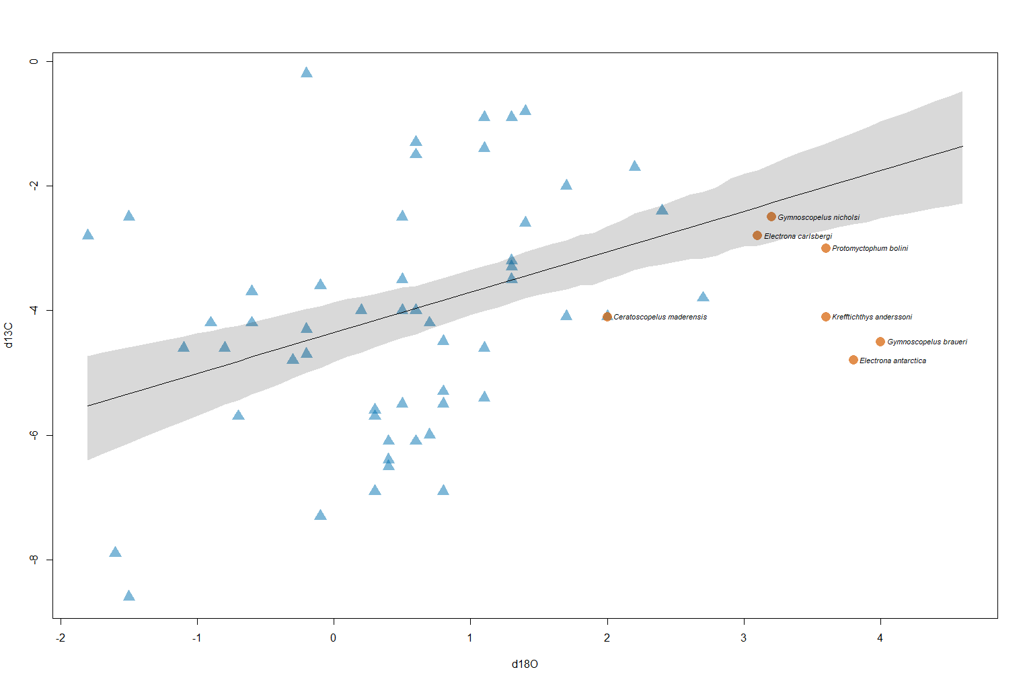

### Caudal Aspect Ratio

* All species, except G. nicholsi, plot outside 95% HDPI, but within range of other species.
  + Lower d13C than expected given K_caud.
  + High metabolic rate for activity level.
  + C. maderensis is also below the line.

